1. 
2. A black background with white text

   Description automatically generated
3. 
4. 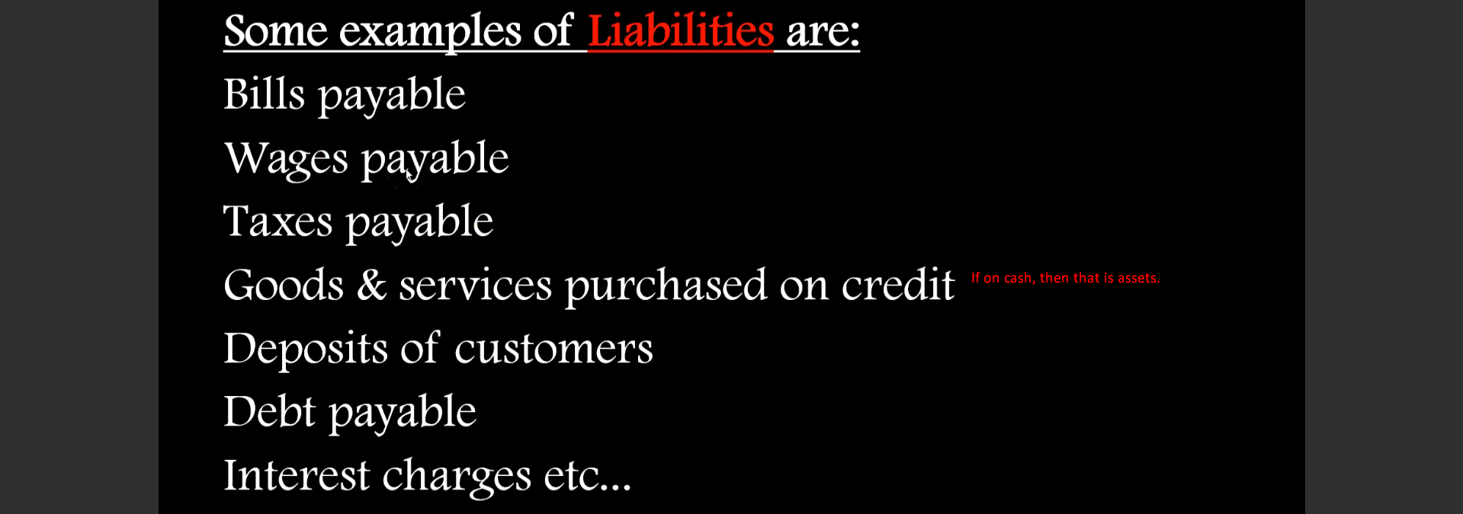
5. <https://www.youtube.com/watch?v=v2mP9gK76mg&list=PLytYcCwHZt2yAaCwtkdBVxqJcHQtbETCF&index=2>
6. **Liabilities**
   1. Internal: Owed to owner.
   2. External Owned to outsider like bank.
      1. Current Liabilities: To be paid within 12 months (intention matters).
      2. Non-Current Liabilities: To be paid after 12 months since balance sheet is made.
         1. Creditor.
         2. Short-Term Loan.
         3. Outstanding Expenses: Salary Due to be paid to an Employee.
7. **Trade Receivable** = Bill Receivable + Debtor
8. **Trade Payable** = Bill Payable + Creditor
9. **Liability, Provision (like Tax)**